August 28, 2015

Charlie Jones
C3 Presents
300 West 6th Street, Suite 2100
Austin, Texas 78701

RE: Guest Passes to the 2015 Chicago Food + Wine Festival

Dear Charlie,

I am writing to express my appreciation for your invitation to attend this year’s Chicago Food + Wine Festival. I am positive it will be a fantastic event. Unfortunately, given the valuation of these passes, the City’s Ethics Director has advised that we err on the safe side and decline your invitation. As such, I have enclosed the four “all-in” passes that were sent to my office earlier today.

Again, we certainly appreciate your invitation to attend the Festival and wish you all the best as your event gets under way.

Sincerely,
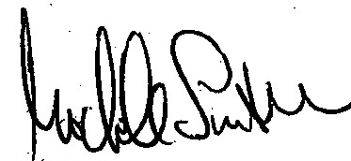
Michele Smith
Alderman, 43rd Ward

cc: Steven Berlin, Executive Director, Board of Ethics

