From: Les Bond [mailto:LesBond@attucksfunds.com]
Sent: Wednesday, January 13, 2016 12:21 PM
To: Berlin, Steve
Subject: RE: Disclosure of Financial Interest in IGM, LLC

Steve,
I am updating my disclosure to the Ethics Board with respect to my ownership interest in IGM, LLC by the attached letter. It is my understanding that the Board wished for me to do so in connection with IGM’s application to the Zoning Board for a dispensary license at 8554 S. Commercial Avenue. Les Hollis, President of IGM, asked that I send it on to Patrick Murphy at the City but my contact in the past had been with you.

If you have any questions, please feel free to call me.

Very truly yours,

Les Bond, Jr.
Chief Executive Officer
Attucks Asset Management, LLC

LESLIE F. BOND, JR.
321 N. Clark St., Suite 1450
Chicago, Illinois 60654

January 13, 2016
Via Electronic Mail
Chicago Board of Ethics
740 N. Sedgwick St., 5th Floor
Chicago, IL 60654
Re: Disclosure of Financial Interest in IGM, LLC
Ladies and Gentlemen,
I serve on the Chicago Plan Commission. I am also the owner of a financial interest in IGM, LLC, an Illinois limited liability company that has been granted licenses to cultivate and dispense medical cannabis pursuant to The Compassionate Use of Medical Cannabis Pilot Program Act. In this connection, I am writing to fully disclose this financial interest in order to comply with the City’s Ethics Regulations as it relates any special permit or zoning variance which IGM, LLC or Harborside Illinois Grown Medicine, Inc. ( an Illinois corporation of which IGM, LLC owns 60% ) has applied for or will apply for in the future to the Chicago Zoning Board of Appeals. I have previously disclosed my financial interest in writing to the Chicago Plan Commission and recused myself from any matter relating to medical cannabis so as to remove any appearance of a conflict of interest.
I am in the process of transferring my financial interest in IGM, LLC to a trust, subject to applicable laws and the Operation Agreement of the Company. I will update the Chicago Board of Ethics as that divestiture progresses.
Please feel free to contact me directly with any questions or concerns you may have with respect this matter.
Very truly yours,
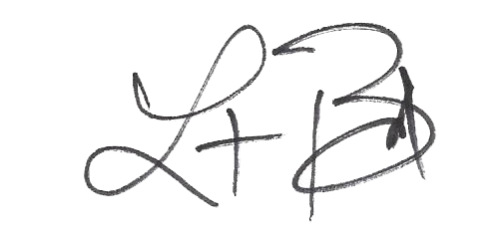
Leslie F. Bond, Jr.

